SIMATS ENGINEERING
ASSESSMENT TOOL 3

COURSE NAME: CSA07 COURSE CODE: Computer Networks

COURSE OUTCOME COVERED

CO1: Apply the functions of OSI layer in enabling reliable data transmission across networks. (BL2, BL3)

Assessment Tool Weightage: 30%

Annexure A

TECHNICAL PRESENTATION

Code of Conduct:

I __B.Vinayani 192472179___ (Name / Reg No) certify that this submission is my original work and that I have adhered to the guidelines specified for this assessment.
I understand that any violation of academic integrity rules will result in disciplinary action.

Signature of the student:

Annexure A

TECHNICAL PRESENTATION

- Role of the OSI Model in Software-Defined Networking (SDN)
- Network Function Virtualization (NFV) and the OSI Architecture
- Artificial Intelligence for Network Traffic Management
- Machine Learning-Based Error Detection in Networks
- Digital Twin Networks and the OSI Model
- 6G Communication Architecture Compared with the OSI Model
- Edge Computing and Reliable Data Transmission
- Cloud Networking Through the OSI Architecture
- Satellite Internet Communication Using OSI Layers
- Future of Reliable Networking Beyond the Traditional OSI Model

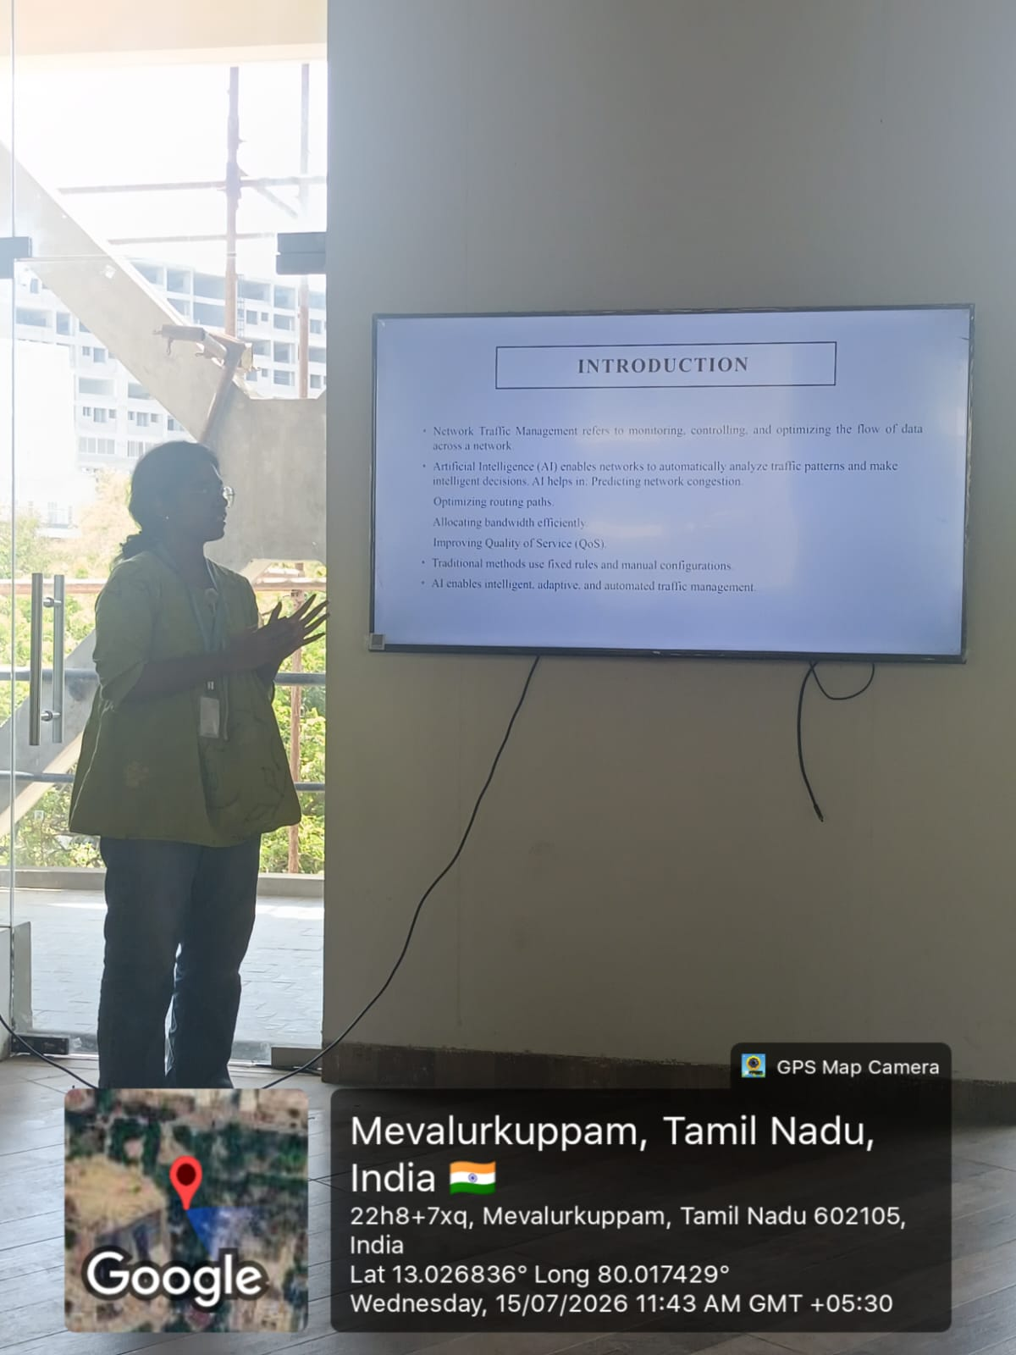

RUBRICS FOR CALCULATION

Criteria | Weightage | Level 4 – Exemplary | Level 3 – Proficient | Level 2 – Developing | Level 1 – Beginning
Understanding of Concepts | 25 | Demonstrates thorough understanding and effectively integrates multiple concepts/technologies | Good understanding with proper integration of most concepts | Basic understanding; limited or partial integration | Poor understanding; unable to integrate concepts
Experimental Design | 30 | Well-planned, systematic implementation with optimal solution | Correct implementation with minor issues | Basic implementation with errors or inefficiencies | Incorrect or incomplete implementation
Use of Tools | 20 | Effective and advanced use of tools/technologies with proper configuration | Appropriate use of tools with correct execution | Limited or inconsistent use of tools | Incorrect or minimal use of tools
Analysis of Results | 15 | Insightful analysis with accurate interpretation and validation of results | Good analysis with reasonable interpretation | Basic analysis with limited insights | Poor or incorrect analysis of results
Documentation | 10 | Clear, well-structured documentation with diagrams, code, and results | Organized documentation with necessary details | Basic documentation with missing details | Poor or incomplete documentation

